Spatial Correlation of Dog Bites. Do parks matter?

I. Undergraduate Analysis of Dog Bites, Anna Smith

Summary

Using R to find spatial correlation between dog bites in the boroughs of NYC. Using spatial correlation techniques, I will attempt to see if there is any correlation between the number of parks in a borough to the number of bites.

1. Introduction

My study area is the boroughs of NYC. I want to see if there is a connection between the number of bites within a borough and the number of parks for 2015.

This could be important because many people relax when at a park. People do not pay as much attention when relaxing, watching their children play on playgrounds, at a dog park or even on a leisurely stroll on a walking path. Many people tend to let their dog off-leash when participating in these activities – even with leash laws.

I do not believe anyone else has done a study trying to identify the number of dog bites and parks. There are records and studies of the number of bites with breeds within boroughs of the corresponding zip codes. I will add two additional columns to this research named “Park” and “NumberPark” respectively. I will also use a shapefile containing the boroughs and respective zip codes of NYC provided by Department of Information Technology & Telecommunications (DoITT).

2. Data and Methods
My method for finding parks within the zip codes was easy enough. When searching for the parks, I believed the best method would be to search “parks located in 10001 zip code” in Google. In this day-in-age, when any person wants to find a location it is being searched for by Google Maps or Apple Maps. Moreover, I did not look beyond 3 pages of the search for the parks. The reasoning is simple – no one looks beyond a couple of search pages to find anything.
- I believe I will abandon this analysis after publishing online. This was a topic that was interesting, but I am still unsure what specific field of study I want to focus on.
- I am unsure if I would do anything the same if I ran this analysis again. I believe I would take a statistics class, before trying another type of analysis like this again. Also, I would like to take another course using R to become more familiar with the program and the specific syntax that is used when coding the tests.
- The tests I used were Shapiro-wilks test, and linear regression. Testing the “Borough” against the “NumberPark” for normal distribution in the Shapiro test. And found that the “p-value” for all boroughs were not within normal distribution. This was not surprising. Many more dog bite observations, than the number of parks within the respected boroughs.
- The linear model results were puzzling. I was unsure as to interpret the results.

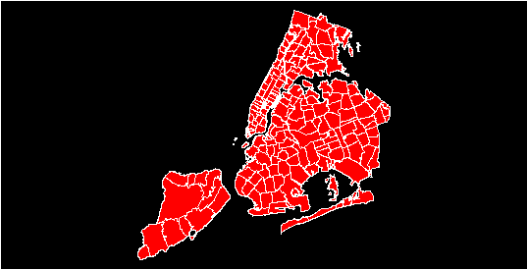
Figure 1. Boroughs of NY and all zip codes.

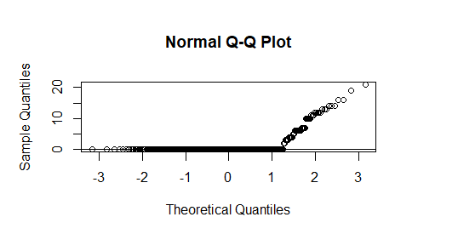
Figure 2. Brooklyn and Number of Parks.
3. Concluding Remarks
This was a simple, yet difficult project. From the analysis, most dog bites do not happen in or around parks – if this was the case the shapiro test would be a normal distribution. New York is also a large city, with the majority of the population living on Manhattan Island. This could also skew the results. Perhaps if the analysis were to compare dog bites to the population, there might be a different outcome. This is the link to my GitHub for code: https://github.com/Annaks91/Ragnos
4. References
Open Data, NYC. Department of Information Technology & Telecommunications (DoITT). April 8, 2014.Update September 10, 2018. https://data.cityofnewyork.us/Business/Zip-Code-Boundaries/i8iw-xf4u
Admin, D. (2018). DOHMH Dog Bite Data - dataset by city-of-ny. [online] Data.world. Available at: https://data.world/city-of-ny/rsgh-akpg [Accessed 1 Nov. 2019].
For further information on this project contact:

Anna Smith
Anthropology and Geography Major
Miami University
Oxford, OH 45056

Phone: (513) 529-1809
E-mail: smithak4@miamioh.edu

Link to code: https://github.com/Annaks91/Ragnos

Justin
Miami University
Oxford, OH 45056

Jessica L. McCarty, Ph.D
Dept. of Geography
Miami University
Oxford, OH 45056

